Appendix 1

E.V. Gray Detailed Time Line

1956
… E.V. Gray, his wife Geraldine, and 8 children arrive in Santa Monica, CA to establish an auto-body fender shop called “Broadway Collision”.

… Gray opens a second shop at 1662 S. Sawtelle Blvd in West Los Angeles.

…. Gary establishes a friendship with a neighbor Marvin Cole ‘Pieria’, educated as a mechanical engineer with an MS degree who prefers to work as a chief at “The Grotto” on pier #57. Gray teaches Marvin secrets of the auto-body trade.

… Gray brings Marvin a working toy (or plans for one) that blasts small coils of copper wire high enough to hit the ceiling. Gray bought or traded for this device from a customer or acquaintance, Dr. Andre (Alexei?) Poppoff.* Gray takes this device to Marvin and proposes that this device be used as the basis for a new kind of high efficient motor. Marvin takes an immediate interest in this idea, since both electromagnetic and electrostatic forces are employed to achieve the huge observed force. Both men spend intense evenings developing plans and ideas. It has been speculated that this circuit was some kind of “Popping Coil” setup that displayed a hefty pop. (Accounts by Joe Gordon and Dr. James Gray)

… An interested relative requests to become part of the project - but is refused. After this event, further development appears to have gone entirely underground. Gray provides personal funds to Marvin in order to afford him more time to be devoted to the project.

1960
… Both day job auto-body business fail and Gray moves his family to Prescott Arizona to start another auto-body fender shop.

… It is assumed that Marvin Cole continues with the motor development in Gray’s absence. Sometime during this ongoing development Cole discovers his prototype is more than just an efficient motor. His design is now producing more energy in torque out than the energy he is putting in from the battery. The whole game changes. It is uncertain just when this transition took place but is estimated to have taken place in 1964.

1962
… Gray ends up in Las Vegas after loosing the family home made motor home in a card game. In time he establishes yet another auto-body fender shop.

* “In 1957, a Russian immigrant to the USA, one Alexei Poppoff, showed Edwin Gray a circuit which he said he had been shown by Nikola Tesla.” - Practical Guide to Free-Energy Devices, chap.5, by Patrick J. Kelly. See free-energy-info.com

1964

… While in Las Vegas (with business going good) Gray constructs some kind of circuit outdoors between two buildings utilizing coils and a car battery. A sizable explosion results - however no injuries are reported. Gray tasks his older sons, still at home, to clean up his mess. (Dr. James Gray account). It is speculated that Gray was testing a circuit sent to him from Marvin Cole who may have discovered something important while continuing development on the Pulse Motor idea.

1965

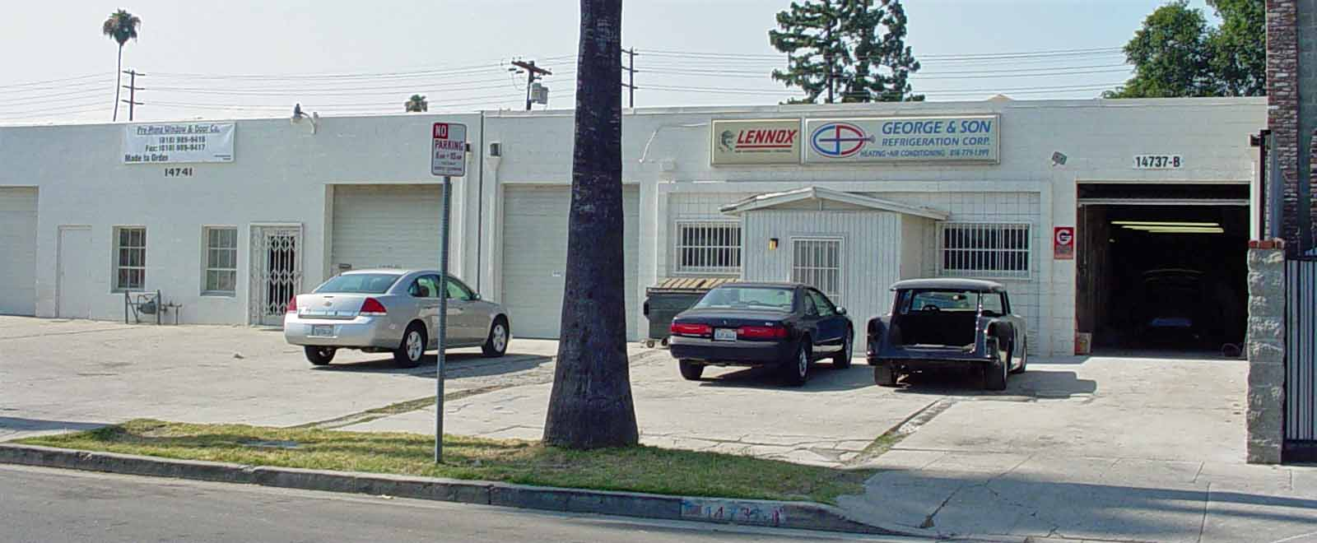

The Auto-Body shop on Calvert Street in Van Nuys, CA in 2007. E.V. Gray’s nephew George Gray was still doing business there. Photo by author

… Gray returns to the LA area and partners with his nephew George Gray to establish “The Body Shop” on Calvert Street in Van Nuys.

… Any further collusion with Marvin Cole is hidden from the family. As far as they know Marvin hasn’t been seen since 1960. It is speculated that Marvin may have already had a group of supporters working on this project. Gray was probably quickly admitted because it was his initial idea and the initial financial contributions.

… While there were financial and technical partners involved it appears than none of them ever perceived the entire novel energy conversion process – since no one ever attempted to duplicate the equipment. It is quite likely that only Marvin made the discovery and was able to keep the non-classical technical details largely to himself.
1968

… Geraldine Gray unexpectedly discovers “the other woman” late one evening at the Auto-Body shop while picking up the weekly bookwork. The relationship with E.V.Gray suddenly ends.

1969

... E.V. Gray sells his Auto-Body business to his nephew George Gray, but keeps 1/2 of the building in Van Nuys, CA to become a motor inventor. The sudden transition baffles family members who have observed no previous interest or preparation for such a profession. There must have been some serious funding source for him to do this. It has been said that 2 geologists, that made it big in some oil venture, where the major source of money at this time. They must have been shown something impressive in order to invest some 1.1 million (1970 dollars) in this venture.

... Gray divorces his first wife Geraldine, of 22 years, and 10 children.

1970

... E.V. Gray has established a group of “Insiders” who collaborate to build a novel motor. By this time the OU properties of the technology have been established well enough to inspire others to invest in this enterprise.

… James Gray (second son and mechanical engineering university student) works part time for his father by drafting motor parts (specifically a motor case) to be sent out for fabrication. At this time a majority of the components are fabricated by local machine shops then assembled by the “Insiders”.

… Marvin Cole establishes a relationship with the Mallory Electric Company of Nevada to build custom high voltage ignition coils. At some point the company owner ‘Boot’ Mallory begins to contribute money to the research effort. (Source: GD documents (Graphic Design?) )

1971

… E. V. Grays marries the other woman Ms. Renate Lenz. Her father Fritz Lenz (a former Volkswagen engine rebuilder) goes to work for Gray as a machinist/technician. Shops tools are secured (or leased), specifically a 12” lathe and a Bridgeport Vertical Mill. From here on almost all of the smaller motor parts are machined in house. The motor cases are still contracted out.

1972

… Marvin Cole, the inventor of this technology, suddenly bids Gray farewell (or just disappears). Gray is convinced that Marvin is not coming back. Gray then takes all this work and equipment as his own and attempts to profit handsomely from it.

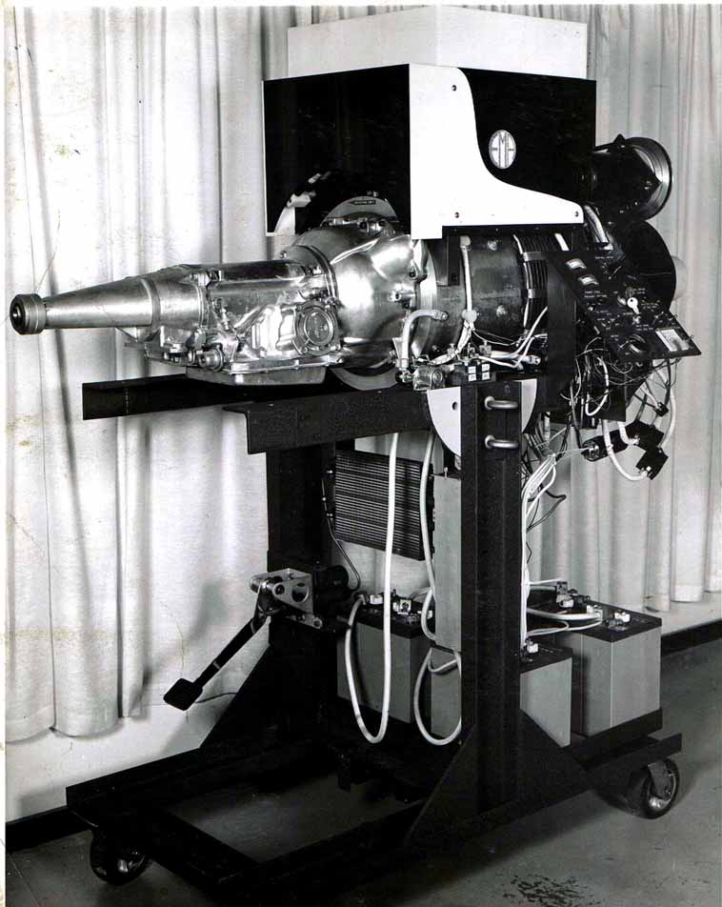
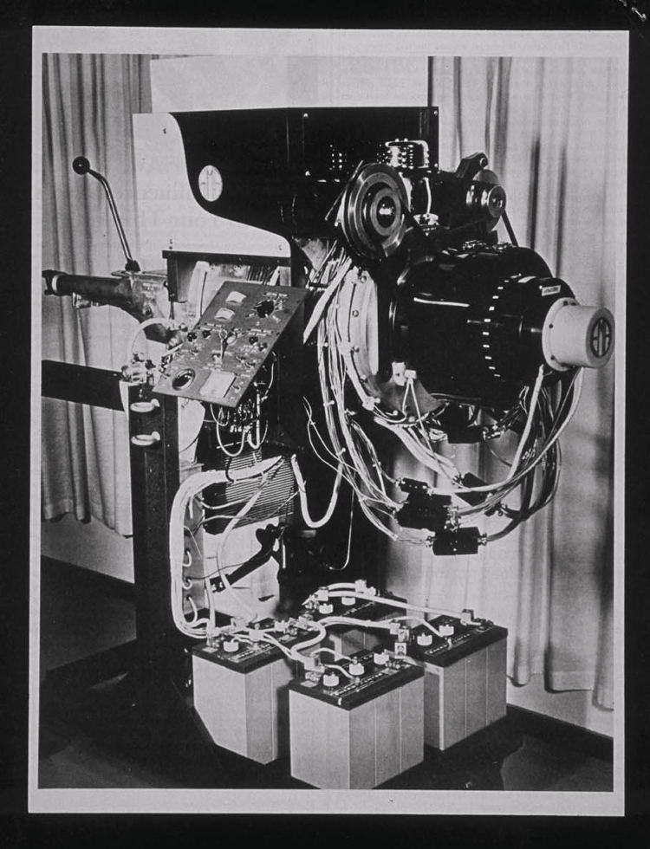

The EMA4 Free-Energy Engine 1973 two different stages of development

… Gray starts a search for a new engineer. Robert Beck, a well known ex-military expert in novel magnetic systems applies for the job. After the initial interview,
Beck withdraws his application when he realizes that Gray was not the originator of this technology. It is also rumored that Beck also catches Gray recharging his batteries in the middle of the night during some test. (Beck’s summer retreat roommate)

… Richard Hackenburger, an EE graduate from Western University with 25 years of professional experience in Silicon Valley applies for the job. Gray hires ‘Hack’.

… Gray and “Hack” begin courting large cap companies to hock their wares. Attempted sales to the domestic car manufactures fails completely because nobody believes the outrageous claims and Gray will not release a prototype for evaluation. However some foreign concerns show an interest.

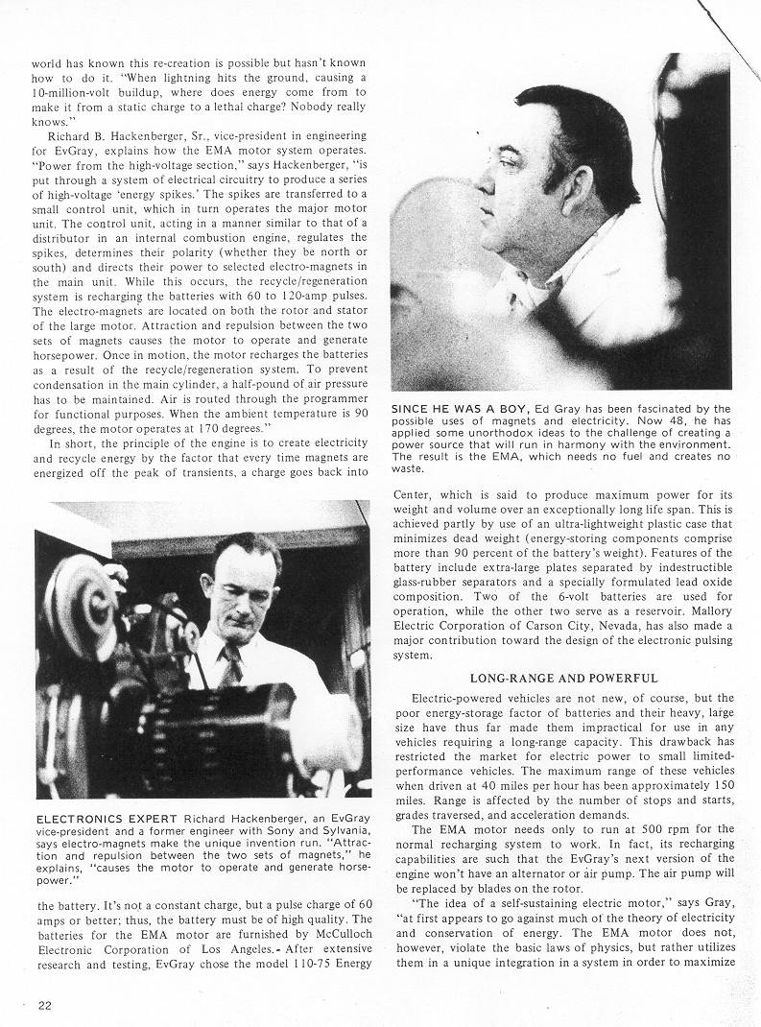

E.V.Gray and Richard Hackenberger in 1973 Photos by Jack Scagnetti

1973

Jan E.V. Gray signs a letter of intent with representatives of the Pan American Enterprises (A Japanese partnership) for a $12.5 million research contract along with provisions for future licensing agreements for Asia. It is said that if all the
licensing options were exercised then the total fees would come to a billion
dollars (in 1973 money).

May 1 - Pan American Enterprises contracts with Crosby Research to conduct 10 days of testing

May 10 of the E.V. Gray equipment. (It is assumed that the EMA2 motor was tested) These investigations take place at leased facilities at Cal-Tech with additional tests being done at the Van Nuys location. Y. Akiyama (Engineer) and Takuo Sato are the representatives from Pan American Enterprises during these trials. During these tests two Cal-Tech researchers are so impressed with the performance of this technology that they take a serious interest in it. Dr. Norm Chalphin and Dr. Gene Wilder (both of JPL) joined with Gray and became board members.

May 28 Mr. Chris Gutier (assumed to be an “insider”) submits a three page theory paper describing one very important novel feature of this technology. (GD document)

June The Probe the Unknown Article is written by Jack Scagnetti “The Engine That Runs Itself”. This is the first public announcement of this new technology. It is important to realize that the date listed here is when this monthly magazine was published, which means that the photos and data are at least two or more months old. There are certain differences in the photos that are of technical interest when compared to the later Tom Valentine photos. Mr. Scagnetti also mentions some 200 stock holders and the staff Mr. Gray has employed:

Richard Hackenberger VP of Engineering
Arthur M. Lange VP of Public Relations
George C. Demos VP of Marketing
Fritz Lenz Machinist (Father in-law)
Renate Gray Office Manager (second wife to E.V. Gray)

July 1 Mr. Tom Valentine publishes the first Tattler Article. "Man Creates Engine That Consumes No Fuel; Invention Could Change History By 1984" (Part 1)

July 8 The Tattler 2nd Article is published “Miracle No-Fuel Electric Engine Can Save U.S. Public $35 Billion a Year in Gasoline Bills.” (Part 2)

Sep 27 Mr. J.A. Maize, Director of Engineering at Crosby Research submits a letter and finished report to his boss Larry Crosby summarizing the findings and importance of the tests done on the EMA motor in May. This is the keystone document to support the validity of this technology.

Oct This is the proposed time period that Mr. Dowd Cannady visited the E.V. Gray laboratory.

Nov. 2 Gray’s 1st patent “Pulsed Capacitor Discharge Electric Engine” is submitted for approval, written largely by Dr. Norm Chalphin but edited to obscure any novel energy conversion process.

Nov. 23 Pan American Enterprises pulls out of the project, partially due to a lack of available funding and partially because of a major breakdown of the EMA4-E2. It has also been speculated that they probably came to the conclusion that Gray was not the originator of this technology because of his complete technical inability to troubleshoot the failed equipment.

Dec. 6 Mr. Hackenburger writes a 5 page technical white paper for company handout information, most likely to support the search for a new funding source. A reference is made to 600 stock holders who have already invested.

1974

Jan 1 The first "Fascination," prototypes were due. The Fascination car trials were then dropped. It is reported that Mr. Paul Lewis was very disappointed in Mr. Gray’s ability to deliver on his promises.

Jan GD makes his first trip to Van Nuys. He secures an informal franchise agreement to sell Electrostatic Generators in 5 North West states.

March Mr. Hackenburger releases another status report, shorter than the first and vaguer.
Negotiations with the Denver group have started for the domestic licensing of this technology.

May GD makes a second trip to Van Nuys to introduce a potential investor to Gray who is interested in manufacturing Electrostatic Generators.

Jan. 24 Tattler Article #3

July 22 25+ armed law enforcement raiders from the Los Angeles County District Attorney's office descended on Grey's laboratory in Van Nuys. They confiscated plans, records, the latest working prototype of the motor, plus what ever else they could find.

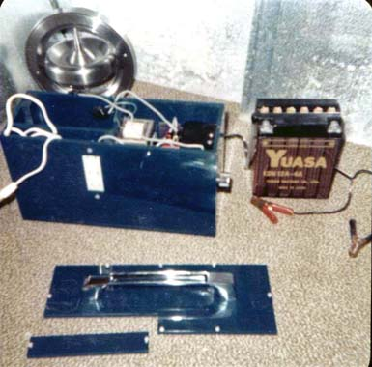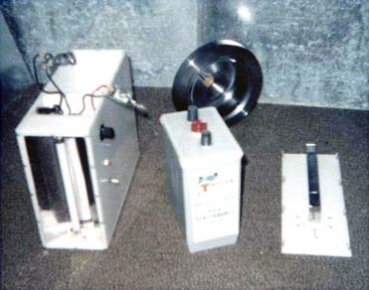

July 26 GD receives two each 2nd Generation “Electrostatic Generators” for safe keeping and marketing displays that were outside the laboratory stored in vehicle trunks during the raid.

Dec.1 The annual share holders meeting is attended by GD who spends a lot of time with “Hack”. Litigation is in progress against ex-business manager Mr. George C. Demos who is alleged to have fingered Gray to the LA DA. The EMA6 motor is on the drawing board. GD returns the Electrostatic Generators.

1975

Feb. 12 Share holder letter bemoaning the actions of the LA DA. Expenditures for the past accounting year came to $311,042. Negotiations with the Denver group are continuing. 1st patent is in progress with 18 claims being accepted.

April 15 Gray’s lawyer’s file for a motion to return the seized equipment.

April 21 The mid-year stockholders report is released. Agreements have been reached with the “Denver Group” to execute two exclusive master license agreements, one for the motor and another for the Electrostatic Generator. The Denver Group releases $500,000.00 to Gray as a partial license fee payment.

May 1 Gray sells the remaining half of the Van Nuys building to George Gray and moves the EMA offices to the commercial high rent area near the LA airport. Here he hopes to be more accessible to interested international customers.

May 10 GD is formally relieved of his limited franchise agreement, pursuit to the new deal having been made with the Denver Group. (What do you expect from friends?)

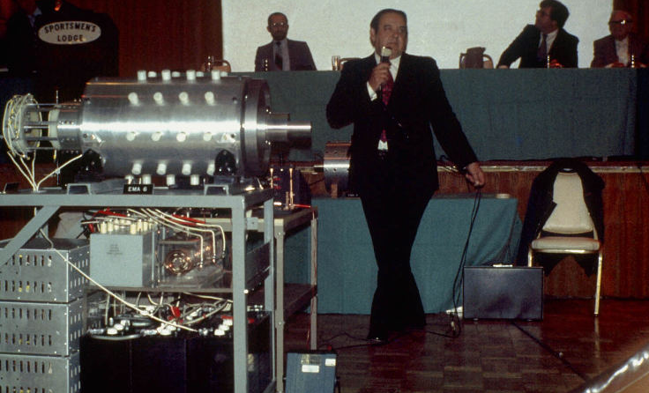

E.V.Gray at the Jan 9, 1976 media event. The new EMA6 failed to perform and no new investment came forward

1976

Jan. 9 The “Media Event” is presented at the Sportsman Lodge, Encino, CA. The EMA6 motor is debuted, which only can produce 2 HP. The board (about 9 members) is top heavy with lawyers. Little to no money is available for technical development or prototype fabrication. No new investors were interested in what was presented. (2 HP just doesn’t cut it)

Feb. Gray is nominated for “Inventor of the Year” by Dr. Norm Chalphin and Dr. Gene Welch. (he didn’t win the award – but who was going to vote for a jail bird?)

March The D.A.'s office brings a series of charges against Gray, including grand theft, by claiming he had raised money from investors by means of a hoax. But all the serious charges were dropped when it when it was proven they were unfounded. It is reported that none of the stockholders would testify they had been cheated. Gray pleads guilty to a couple of reduced securities documentation violations. He (or his lawyers) promptly pays the associated fines and the case is closed. This event is perceived by Gray to allow him go full steam ahead with plans to sell technology licenses worldwide. The only problem is that he doesn’t have anything to sell (and he doesn’t even know it).

March 16 The “Newsreal – Suppressed Inventions” article is written by Tom Valentine “EMS – Electronic Power That Could Change the World’s Economic Power Picture”

April The seized prototype motors (the EMA4-E2 and the EMA5 case) and all the other equipment are returned to Gray in large wooden boxes. It appears that most of this equipment had been run through a scrap metal shredder. Even then it is highly unlikely that all of it was returned and that much of it was not even the original equipment (being mixed with other scrap material). The destruction of this property was highly illegal, but Gray was not in a financial position to contest it. The damage was irreparable and what ever secrets held in the Marvin Cole equipment was now lost. The only hope now was that what ever Hack had learned while he had past access to it. It appears that at first he really didn’t have a complete understanding of the non-classical process but might have figured out the missing parts in the years to come.

May 14 GD visits Gray and Hack for the last time. Hack may have figured out some of the design elements he left out of the EMA6 motor. He has redesigned the commentator and eliminated the CSET device. The last GD photo is taken of the modified EMA6

June 17 1st Pulse Motor US patent #3,890,548 is granted to EV GRAY Enterprises. It is not clear at this time as to who actually owns the rights.

July The Denver Group sues for control of the technology claiming that Gray has defrauded them. [This is a common strategy for large companies to extract patents from cash starved individual inventors] Gray’s lawyers (who are now working pro-bono) inform him that he will have to hire (expensive) counsel in Colorado to contest the suit because that is where the contracts were signed. With the payment funds cutoff Gray has little money left to carry out effective defensive litigation.

Aug The one-sided litigation continues as Renate, Gray and her father Fritz Lenz join the opposition in an attempt to recover some profit from this technology, since Gray seems to be in a financial nose dive and may have reneged on promises made to them. Shortly there after Renate files for divorce, she was married to Gray for 7 years with 3 children. Gray will re- marry three more times.

1977

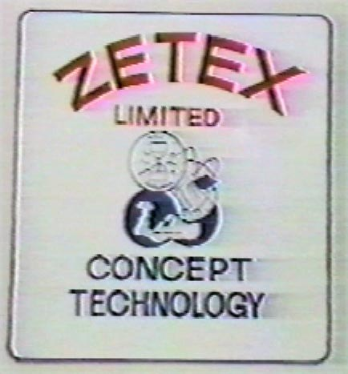
July Gray reorganizes under a new company named “ZETEX” and then removes all the hardware technology to a non-disclosed storage facility. This action leaves all the previous investors with worthless stock certificates, many in the Kansas /Iowa area. However Mr. Russell Audrey maintains a strong belief in the technology.

… The Denver oil company comes to realize that the patent does not provide a workable Free Energy Motor and that Gray probably doesn’t know how to produce one. It is unclear just what their real motives were. It is unlikely that the litigation ever reach the courts since Gray was broke and they already had public access to the patent documents plus any other documentation that Gray or Hack might have released to them during the honeymoon period. If they wanted to manufacture the motor or the Electrostatic Generator they could have. Gray would have been unable to stop them since his legal position was very weak, given the previous maneuvering. Since neither technology made it to the market (that we know of) there are two main conclusions 1.) They couldn’t get either technology to work 2.) They had
no intention of manufacturing any of this in the first place and were only interested destroying any possible competition. They also could have been proxy agents for some other interest who wanted to achieve the same ends.

Aug Gray and Hack are living hand to mouth while still attempting to get the EMA6 to run properly. Hack has taken a job as a taxi driver to pay the rent. He remains in the LA area with Gray rather than go back to San Francisco or searching for a real engineering job, which he was well qualified for.

… ‘Boot’ Mallory dies in a car accident.

1978

… While improving the EMA6 Gray and Hack are raided again. This time by the FBI acting as armed agents for the FCC who had picked up illegal levels of RF emission. They took everything, even Hacks soldering gun, and were none to polite about it. The EMA6 motor and any other electronic looking hardware was immediately destroyed under the provisions of the “War Powers Act”. A majority of the office equipment is eventually returned when it is determined that Gray was not intending to communicate with Communists. However the FCC told Gray and Hack to never work with this technology again and that they would be watching. There were probably fines associated with this incident; however Gray was unable to pay them.

1979

… E.V. Gray, his son Mark Gray and Richard Hackenberger load up a truck of demonstration equipment and head to Kalona, Iowa to continue development with Russell Audrey providing the funding. It is thought that the “Blue” Motor was fabricated at this time. This would have been Hacks second chance to make a working motor. Perhaps he got closer than with the failed EMA6. How far he got in reproducing the performance of the EMA4-E1 (or EMA2) is unknown.

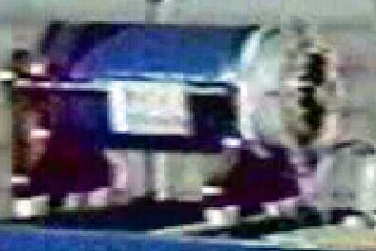

The EMA7 aka “The Blue Engine”

… The deal falls apart as Gray perceives that Mr. Audrey is attempting to confiscate his technology or Hack actually does “re-discover” the method to extract excess energy. Again the three men load up their U-haul trailer in the middle of the night and escape back to San Diego, CA during a very cold winter. They appear to have taken the “Blue” Motor with them, which is no doubt an item of questionable ownership.

1980

… Richard Hackenberger takes ill and dies within a week. (Maybe that winter escape got him?) His family in Oregon doesn’t know of his death for a month.

… Gray hides out in San Diego for 18 months, probably looking for new investors and hiding from Mr. Audrey. It is suspected that the Blue Motor did show some promise but was incomplete. With Hack gone Gray needs someone else to finish the project. The only problem is that he can’t really tell them what needs to be done.

1981

… Gray set’s up shop in Canyon Country, CA under the name of “American Medical Electronics”. He hires a new Engineer also named Richard (Richard II) who is an older albino engineer. He also hires two additional younger assistants. Funding is now coming from two members of the Jewish community who have faith in Gray’s work. Richard II is exploring systems that switch the motors with large Thyratrons and other vacuum tube solutions. Much closer attention is paid to EMI shielding, least the FCC come calling again.

… Gray hires Nelson Schlaft ‘Rocky’ (a former military aircraft electronics technician) from a news paper add who will eventually replace Richard II. At this time Gray has a research staff of 5 people. After two months Rocky confronts Gray and says he can no longer work with Richard II because of his PTSD type of attitude. Gray asks Rocky to stay on until his next move.

1982

… Gray stages a mock closure of his laboratory as a means to eliminate his excess staff that seems unable to make any sale-able progress or work with others. Gray favors Rocky who seems to show more promise. E.V. Gray, his son Mark Gray and Rocky then move to a new location in the same town. This decision to go with Rocky may have been fatal to the technology. Unfortunately Gray didn’t have the technical expertise to know the difference. Richard II may have been closer to recovering the lost pieces than what he has been given credit for. Richard II, like so many before, apparently didn’t see the whole picture and never pursued the technology on their own.

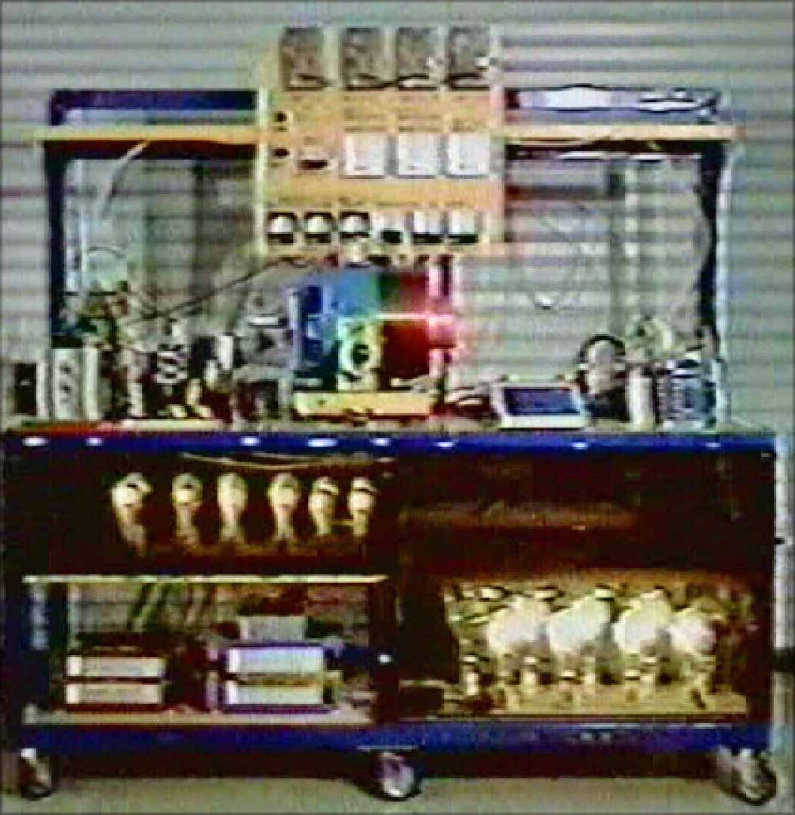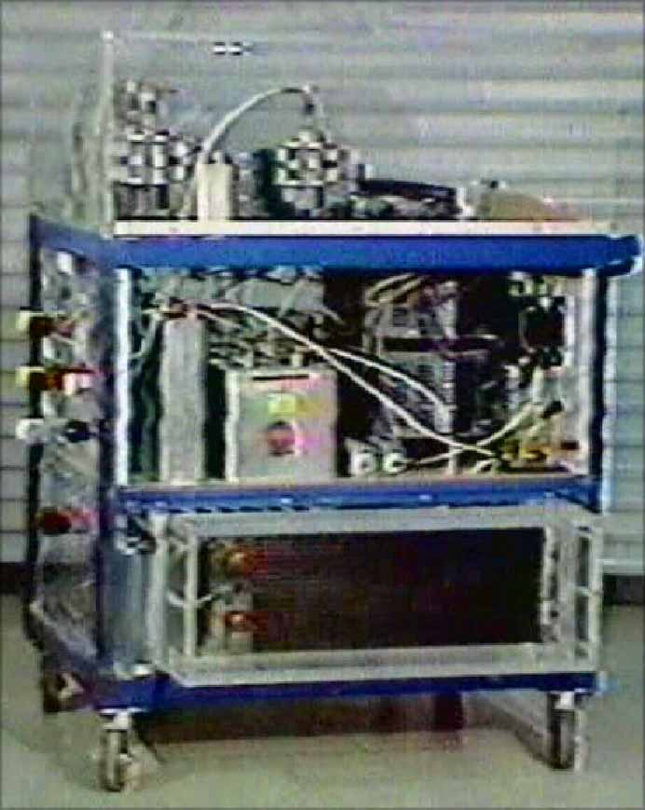

The “Meter Cart” on left and the “Trigger Cart” on right both built in 1983 to promote the E.V.Gray Technology

1983

… Mark Gray and ‘Rocky’ (who worked well together) refurbish 5 different motor display carts with ignitrons, rebuild the “Trigger” cart, and then build a large metering/demonstration cart. Rocky had the motors rewound at a local machine shop, thus destroying the original technology. However, the motors will now run and even start on their own. The huge increase in required electrical power to accomplish this is completely disregarded. Several new presentations of Popping coil models are built. All of this equipment is designed to be mobile and fit into the company truck. Rocky claims that he himself spent about $250,000 in cash outlays for parts and components. Gray paid even more for wages, rent, office expense, and the leases on test equipment (specifically a Tektronix 4904 oscilloscope with probes).

1984

… Gray moves his operation to Las Vegas. Rocky is now placed on a part time cash only contract basis and provides services as needed, which suits his nomadic life style just fine.

1985

… Gray moves his operation to Counsel, ID. His oldest son ‘Eddie’ and his wife have already settled here. This small (population 861) ex-saw mill town offers tranquility, good scenery, clean water, and low rents. Gray sets up shop in the middle of town in a couple of vacant store fronts. Here he focuses on promoting his plastic core electromagnet projectile concept and presents only a passing reference to the motor technology. He most likely fears litigation from Electrotech since they still hold a defendable license for the motor and Electrostatic Generator technology.
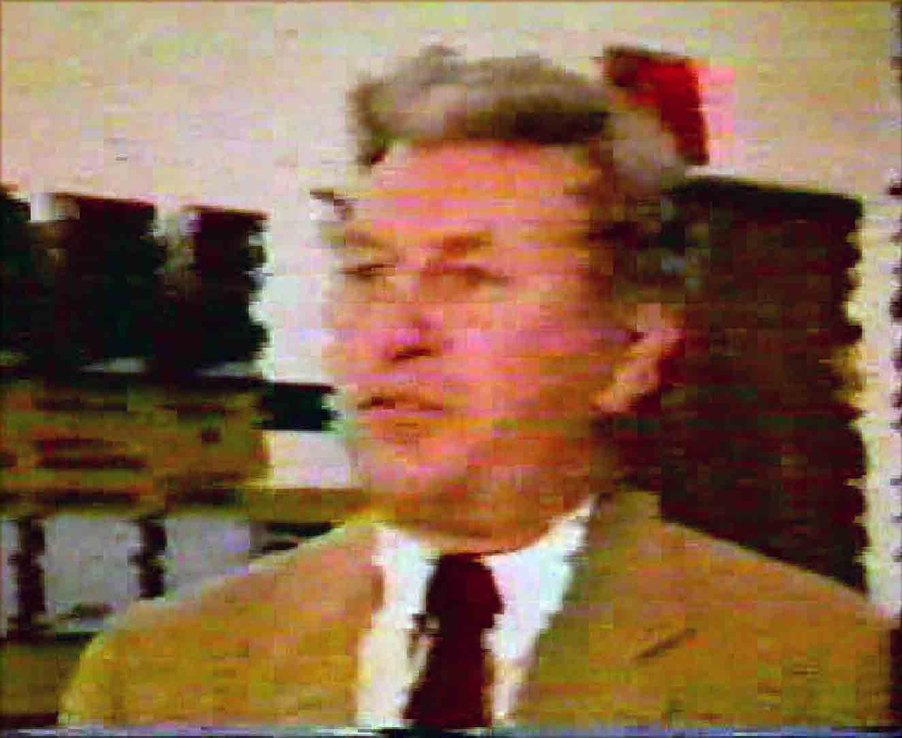
… Gray is not with out security concerns. Rocky is employed to install close-circuit TV systems and build a bedroom trap door in Gray’s nearby trailer house. Never the less Gray still entertains dreams about how he is going to have a huge future press release / media event involving the local high school band and other dignitaries in the football field. Rocky is more sanguine about this possibility.
The lawyer Joe Gordon of Western states Oil 1986
1986

… Gray establishes a business partnership with Mr. Joe Gordon of Western States Oil (a wild cat drilling lawyer from Texas who is working in Montana at the time)

… Presentations of the projectile technology are made to two different military organizations. The reviewers tell Gray that he is insulting their intelligence by offering such a ridiculous solution for consideration. (Account from Mark Gray). Undaunted Gray continues on and searches for more responsive buyers.

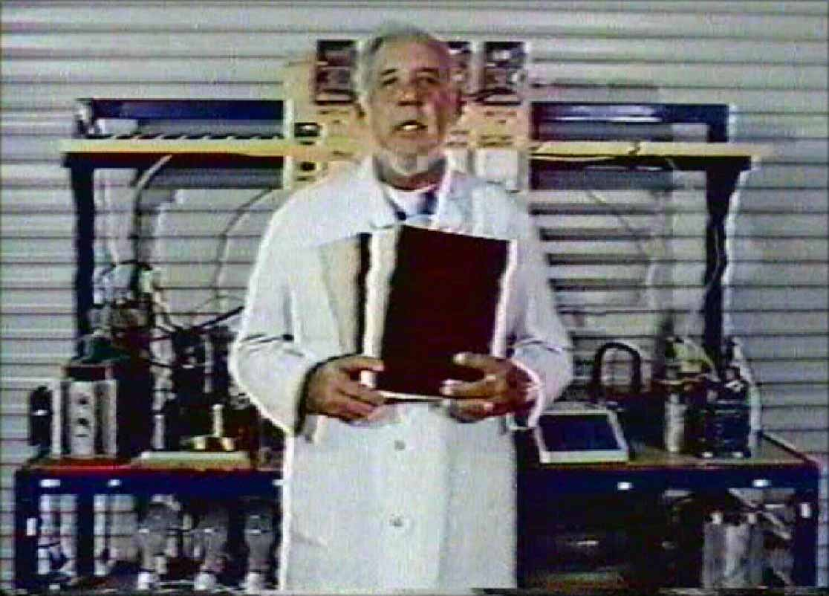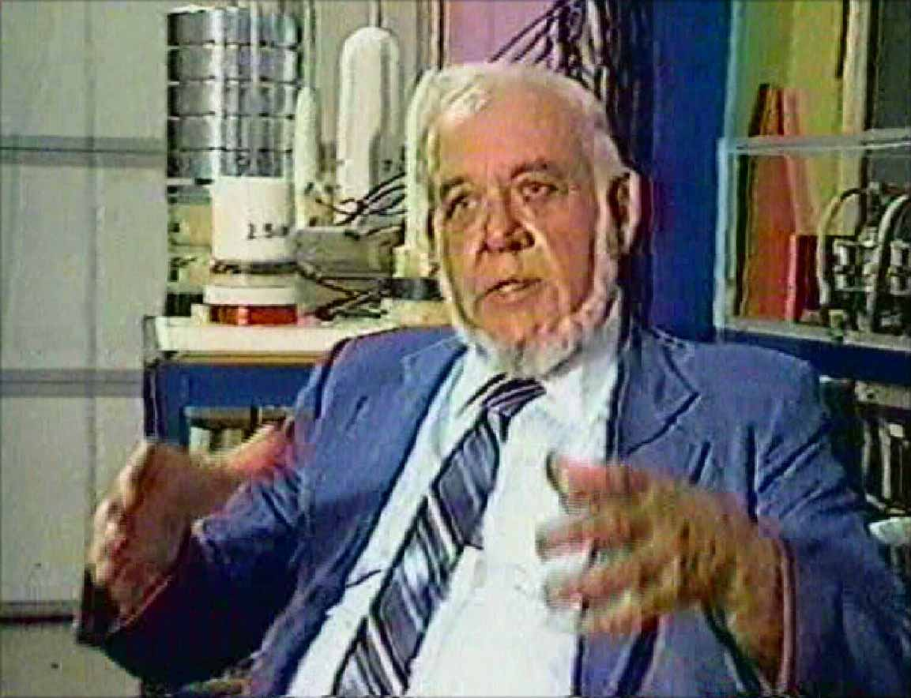

E.V. Gray (61) selling his questionable “Concept Technology” in the 1986 promotion videos

… Production of “The Promotion Videos” from Counsel, ID

… Gray moves his operation to Grand Prairie, TX and produces another promotion video. Gray still maintains his facilities in Counsel since the rent is so low and his son Eddie is there to watch things. Eddie lives on a military pension for trauma suffered in the Vietnam War

… Joe Gordon sets up an off shore office in the Cayman Islands to sell stock in their new company. With the old Crosby evaluation reports and new videos in hand the stock sells rather well. It is rumored that the total stock offering eventually nets about 27 million dollars.

… Rocky parts company with Gray when he is asked to sign yet another stringent secrecy agreement.

… Gray travels to Israel for two weeks, with Mark Gray, to sell his technology. He is offered 9 million dollars but Gray refuses the deal thinking it is worth much more than that and wants to maintain control. No deal is cut.

… Gray returns to Maryland and commences to produce another presentation video along with a letter writing campaign to each member of congress. He offers to give (most likely sell) his technology to the US government. He receives no replies.

1987

… Gray learns that the agents commissioned to oversee the stock sales in the Cayman Islands have absconded will all the money in their control (However, a lot of it was still in a deposit only bank account set up for just this possibility) and left the country for Israel themselves.

… Gray returns exhausted to Counsel, ID

… While in a state of depression (who wouldn’t be after all this) Gray becomes ill with a serious case of Pneumonia. He never fully recovers from this attack and will spend the rest of his life on oxygen supplements. He will enter the hospital at least 4 more times. The various hospitals then seek past due payment from Gray’s second son Dr. James Gray (who has become a minister).

1988

… A self proclaimed government agent Reznor Orr shows up uninvited and makes Gray an offer to buy the technology at some unacceptable low price.

… Mark Gray leaves his father’s employ to get married and avoid all the strange and ominous people now showing up (was there more than one?).

… One of Gray’s business partners (with the Western Oil Company) is killed in a motorcycle/truck accident in California. Gray perceives this unfortunate event to have been a deliberate assassination and is deeply disturbed by it. (According to Joe Gordon).

… Mr. Orr is now making direct threats to Gray pressuring him to hand over the technology. What little money that was coming in from the continuing stock sales and interest in the Cayman Islands is unexpectedly cut off. Gray panics and sells off almost all of his personal family belongings, loads up his truck van and then hides out in Portland, OR for 6 months.

… Gray partners with Dorothy McPhillips (who has a long history with Gray) and they both move to Sparks, NV into a small light industrial facility with living quarters hoping to maintain a very low visibility. Members of Gray’s family don’t even know where he is during this period.

1989
… It is reported that Gray is in the process of disassembling his equipment to hide his “secret”. The shop is located near the local high school by an alley where students pass. Gray’s building is covered with corrugated sheet metal. Occasionally students are known to drag sticks across this wall to create a loud irritating sound.

April Gray dies in Sparks Nevada from an alleged heart attack when unknown prankster(s) drag a stick along shop back wall during the early morning hours. Gray goes out armed to confront the individuals. Apparently he attempts to discharge a warning shot and the gun fails. It is assumed that Gray panics when he realizes he is without firepower. He returns inside and collapses in the living room from the assumed heart attack, he had neglected to take his oxygen with him. He was 64. (Details from Dorothy McPhillips via Ron Hammar)

Conflicting stories about Ed Gray’s Death
The truth about Ed Gray is that he died in April 1993 in a trailer in Riverside, California where he lived with his girlfriend Dorothy. About 2AM, Ed was home alone when something happened and he was later found dead. The police told her he had a heart attack.
Our contact, being a close friend of Ed, was called by Dorothy after the body had been removed by the Riverside police. Although the police said it was a heart attack, our contact noticed a blood stain about 3-5″ in diameter on the carpet where Ed’s body had lain until Dorothy discovered it.
Ed was ‘healthy as a horse’ despite being a big guy, though he did have a smokers hack because he smoked one cigarette after another, but he had no history of heart problems to our contacts knowledge. When our contact asked the policeman why there was a blood stain where Ed had apparently fallen, the policeman said he ‘probably’ struck his head on a counter and blood came from his mouth.
When our contact questioned the detective at the police station house, he was told Gray was very paranoid because he had bilked many investors out of large sums of money and so was always afraid someone would come after him. The detective said a drunken woman had mistook Ed’s trailer for her own and it was she who pounded on the door at 2AM which scared Ed so badly that he had a heart attack and died.
Yet a 3rd story given by another policemen was that Ed opened the door at 2AM and this drunk woman shot Ed thinking it was her philandering husband.
Our contact says this is a ‘load of crap’, confirming that Gray was a big burly man with no history of any heart condition, that he chain smoked and had a smokers hack, but nothing else, was strong as a horse and afraid of nothing.
Since he died alone, by law there had to be an autopsy, yet when our contact tried to get a copy of that autopsy report as a public record, no record could be found that one had been done. It is possible that one was not ordered, however, on further investigation, our contact says he found no records that an Ed Gray ever lived in Riverside, Van Nuys or in Council, Idaho, all have disappeared.
from http://keelynet.com/evgray/evgray.htm
also see family emails about his death: http://pesn.com/2006/02/06/9600231_EV_Gray_motor_reunion/

… “Eddie” and Dr. James Gray fly to Sparks, NV to identify the body. Eddie Gray and his younger sister April had been working to promote the sale of international licenses. Dorothy and Eddie crate up the equipment and have it moved to some non-disclosed storage units in town for safe keeping. Both of them are convinced that malicious people are seeking to steal the technology; they will soon have good reason to think so.

… Dorothy flies to the Cayman Islands in an attempt to recover the remaining bank account, but was placed under house arrest for a week by the local authorities. The alleged millions of remaining investor capital was confiscated by the Cayman Island Government, returned to the investors, or simply swallowed by the bank. Dorothy returned from the Cayman Islands with a much altered attitude.

… Russell Audrey approaches Dorothy McPhillips for release of the surviving equipment, especially the “Blue Motor” which he rightfully paid for. Dorothy refuses to hand over the hardware until she has been compensated for her expenses (and the storage rent) which she has incurred, along with a substantial fee for related pain and suffering. A legal battle follows.

… Russell Audrey secures a court order to have the “motors” released to him. Dorothy, not being without intellectual capacity, separates the “motors” from their mounting stands and supporting power supplies then lawfully turns them over to Mr. Audrey. With out the power supplies, Mr. Audrey has almost nothing that is workable and is in a much lessened legal position to secure them.

… Two shady individuals approach Dorothy clamming to be agents of the INS. They intend to take delivery of all of the remaining hardware as a matter of national security. There will be no compensation. Dorothy quickly calls Russell Audrey and offers to settle for a much reduced figure explaining that if he wants this stuff he had better come quickly with cash in hand or forever loose his piece. Mr. Audrey arrives with 24 hours with a large van and a crew to load the equipment. Mr. Audrey owned a trucking firm. Apparently the alleged INS agents had a coordination issues with the motor pool and were probably unable to make shipping arrangements fast enough.

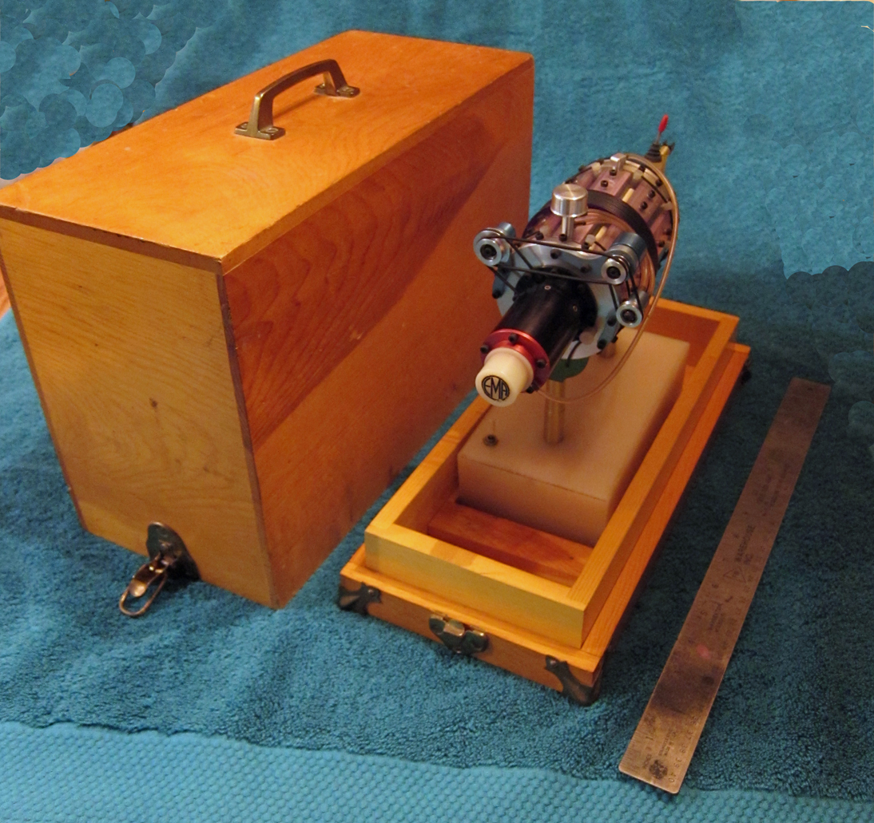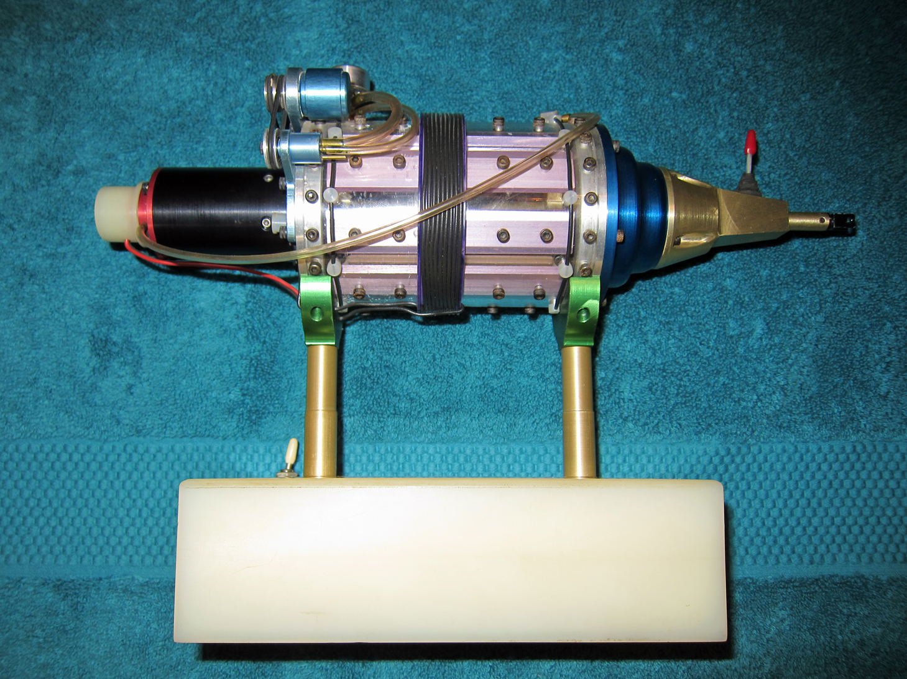

The EMA0 a detailed model of the EMA4 Free-Energy Engine built between 1971 and 1972

… Dorothy spreads the rumor that she had the equipment taken to the dump. She then leaves town with no forwarding address, but she does take the EMA0 model as a personal memento with her. She later settles in Colorado.

1990

… Mr. Audrey takes delivery of most all of the surviving technology hardware and relocates it to Dodge City, KS. It is unknown if he also received any plans, drawings, data, notes, photos, or any other technical documentation.

… Mr. Audrey makes an offer to Eddie Gray to continue work on the motors in Dodge City. Eddie accepts the offer and relocates to Kansas for 8 months.

… Mr. Audrey then seeks out Rocky (who is doing volunteer hospital construction work in Mexico) and offers him a consultant fee to work for a month. Rocky accepts and drives his travel bus 1900 miles to Dodge City. Rocky reports that when he got there most all of the equipment that he had previously worked with, including the spare parts were already there and housed in large well equipped shop. The deal didn’t work out since Mr. Audrey already had on staff a lead engineer who clashed with Rocky on the technical direction the project was headed. Rocky reports that this engineer was also heavily involved in a truck tire recycling plant (owned by Mr. Audrey) and thus had little time to really understand this novel project. The lead engineer managed to burn out the main power transformer on the Trigger cart because he had no idea as to the limitations of this equipment.

… At the end of the month Rocky concludes his contract and leaves Dodge City. This is his last exposure to the E.V. Gray Technology.

… It is assumed that the research and development efforts that Mr. Audrey paid for didn’t reach fruition and the project eventually languished in storage facilities.

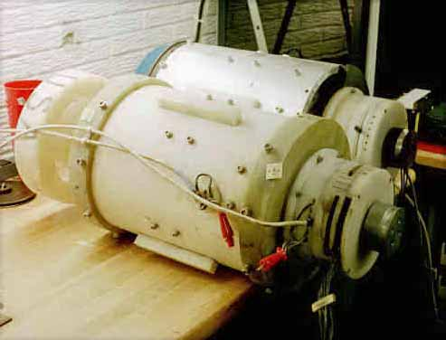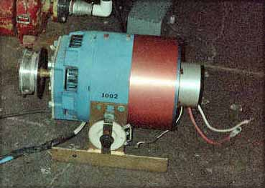

Some of the equipment recovered from Dodge City, Kansas by Norm Wooten and Kenneth D. Hawkins 2000

2000

… Kenneth D. Hawkins (San Antonio, TX) and Normand Wooten travel to Dodge City to inquire about the disposition of any remaining hardware. They eventually discover and purchase two of the surviving 3-pole motors (EMA4 and EMA5) along with some other related equipment.

… Dorothy sells the EMA0 model to Ron Hammar.

2001

… Peter Lindemann, D.Sc. releases his book “The Free Energy Secrets of Cold Electricity”. This is the only book that documents any aspect of the E.V. Gray Saga.

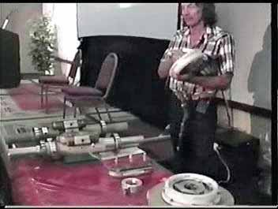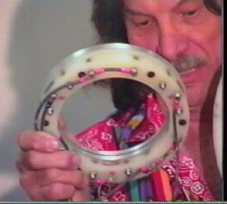

Frame captures from Norm Wooten’s presentation of the E.V. Gray recovered pulse motors in 2001 in Florida

… Norm Wooten disassembles the two recovered motors (the E4 and E5) and makes an impressive presentation at the Tesla Conference in Miami, FL. In his investigation he can’t see where there is any obvious OU process present in this hardware, which is to be expected since these devices were retro-fitted pulse motors and not Free-energy Engines.

... At this same conference Robert Beck contacts Peter Lindemann and shares his experiences with E.V. Gray back in 1972.

2002

… Norm Wooten sells the recovered E.V. Gray motors to Al Francoeur (a Canadian electrician who has invented his own novel motor) of B.C. for $5000 US. Al takes delivery of this equipment and shares details of its construction with other researchers on the Internet, most important the dimensions of the novel electromagnets. He then makes repairs to the EMA4 and continues to find some way to power these historic artifacts. These motors are Al’s most prized possessions.

2009

… Russell Audrey, now in a nursing home, has relatives or business associates contract a broker in California (John D. Riley) to solicit buyers for the “Trigger Cart”, the E1- “Brown Motor” and the E2 “Purple Motor” after he does a technical evaluation of this equipment. Photos of both units look complete (however I would check that main power transformer on the trigger cart). Starting bids are set at $30,000 for each pulse motor and $250,000 for the Trigger cart.

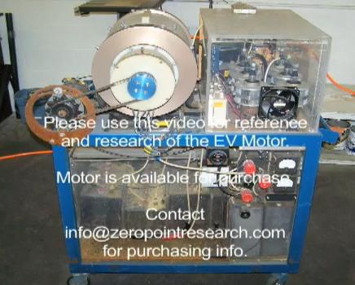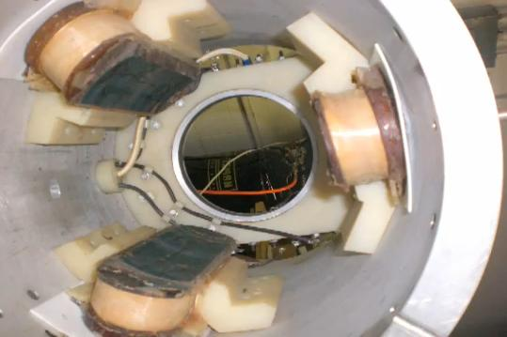
Photos from Mr. John D. Riley’s 2010 YouTube sales presentation

2010
Nov. Mr. John Riley produces a series of quality color photos of the E1 “Brown Motor” for a sales presentation on YouTube.
Dec. A vertical wind mill developer/fabricator in Colorado buys the E1 “Brown Motor” for $30,000. Al Francoeur is allowed to study the motor for a few months.
Dec. 21 Ron Hammer makes the EMA0 available for analysis and documentation.

2011
… The book “The Secretes of the EMA0” is published. It is a collection of Engineering speculations about the lost E.V.Gray Technology mixed with fragments of some of the known history.

